<https://www.imatest.com/docs/colormatrix/#apply_ext>

#### refer to last section- 3. Apply the matrix externally with Matlab code

Use Imatest to compute the color correction matrix

Download Link(15 days trial version)

<https://www.imatest.com/support/download/>

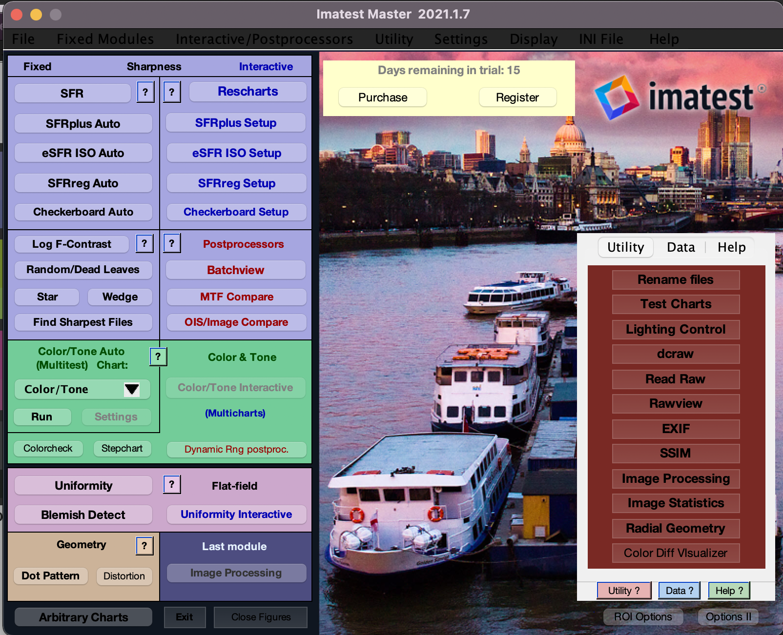



Calculate the matrix at **Color/Tone Interactive** interface

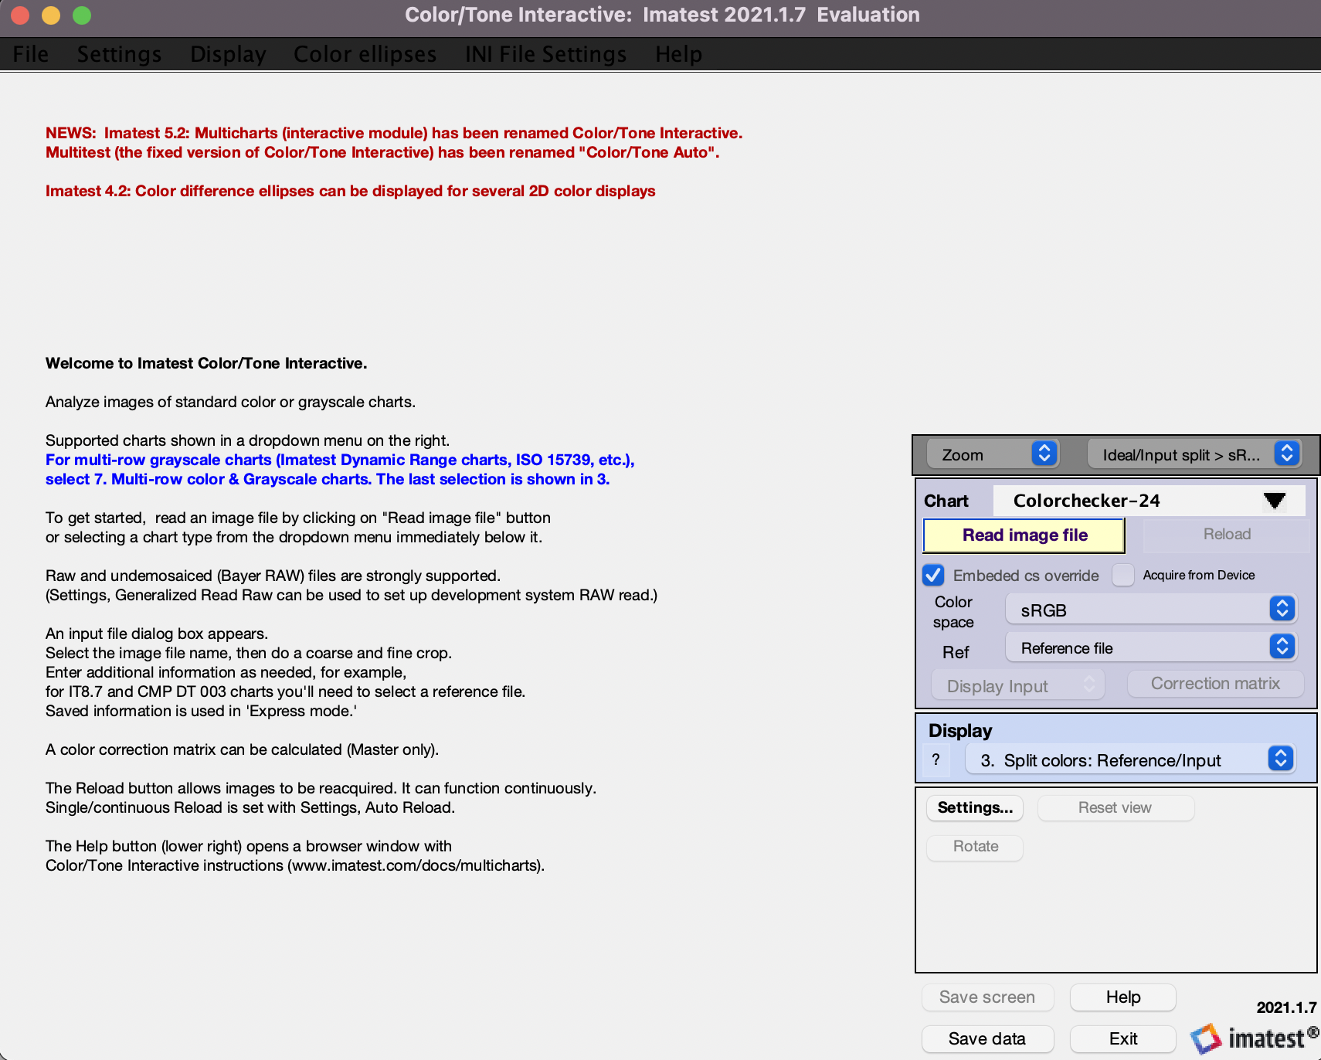

**Read Image File**-> click **Setting**

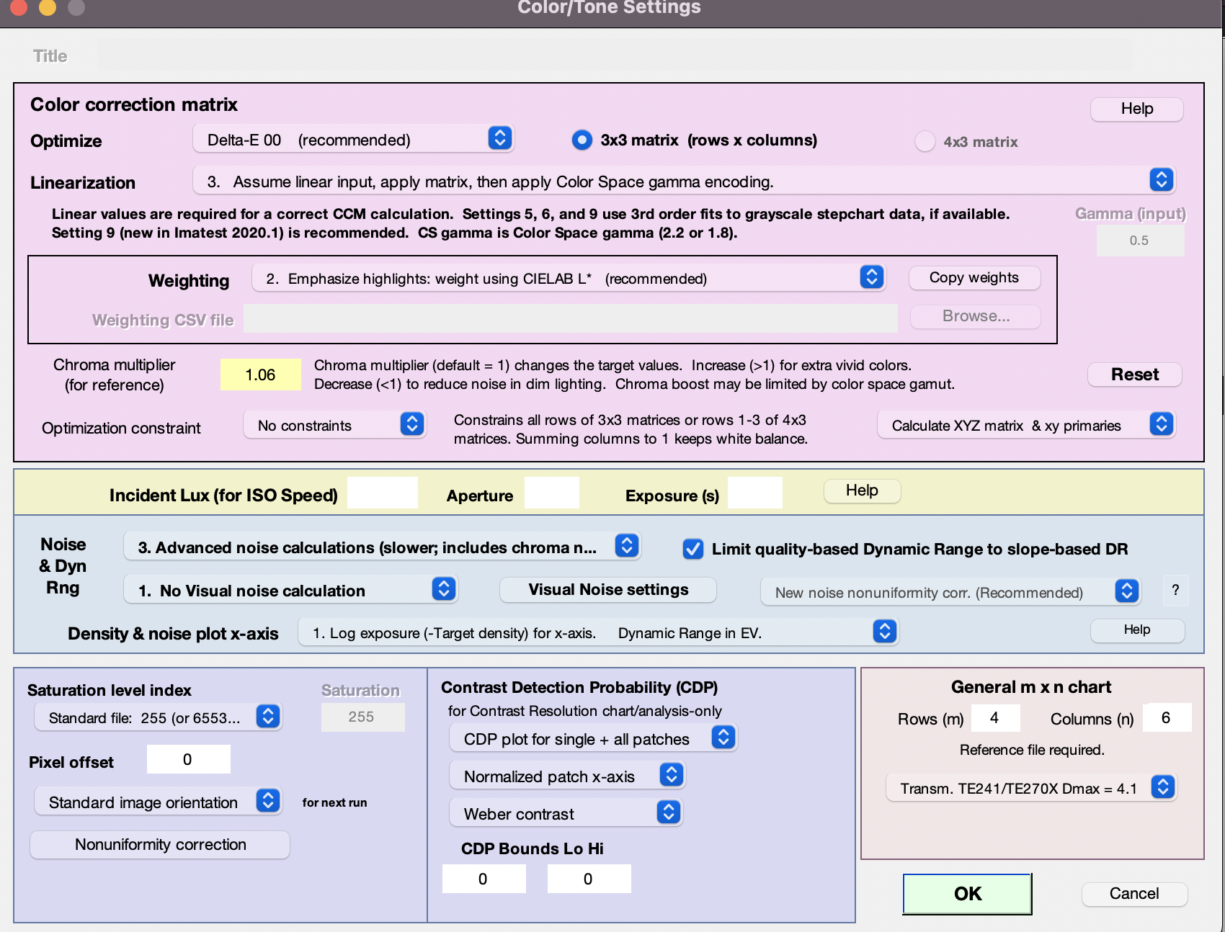

Adjust the below settings and Click **OK**

**Optimize:** Delta-E 00

**Linearization:**  Assume linear input, apply matrix, then apply Color Space gamma encoding.

**Weighting:**  2. Emphasize highlights

**Chroma multiplier:**  1.06

**Calculate XYZ matrix…**

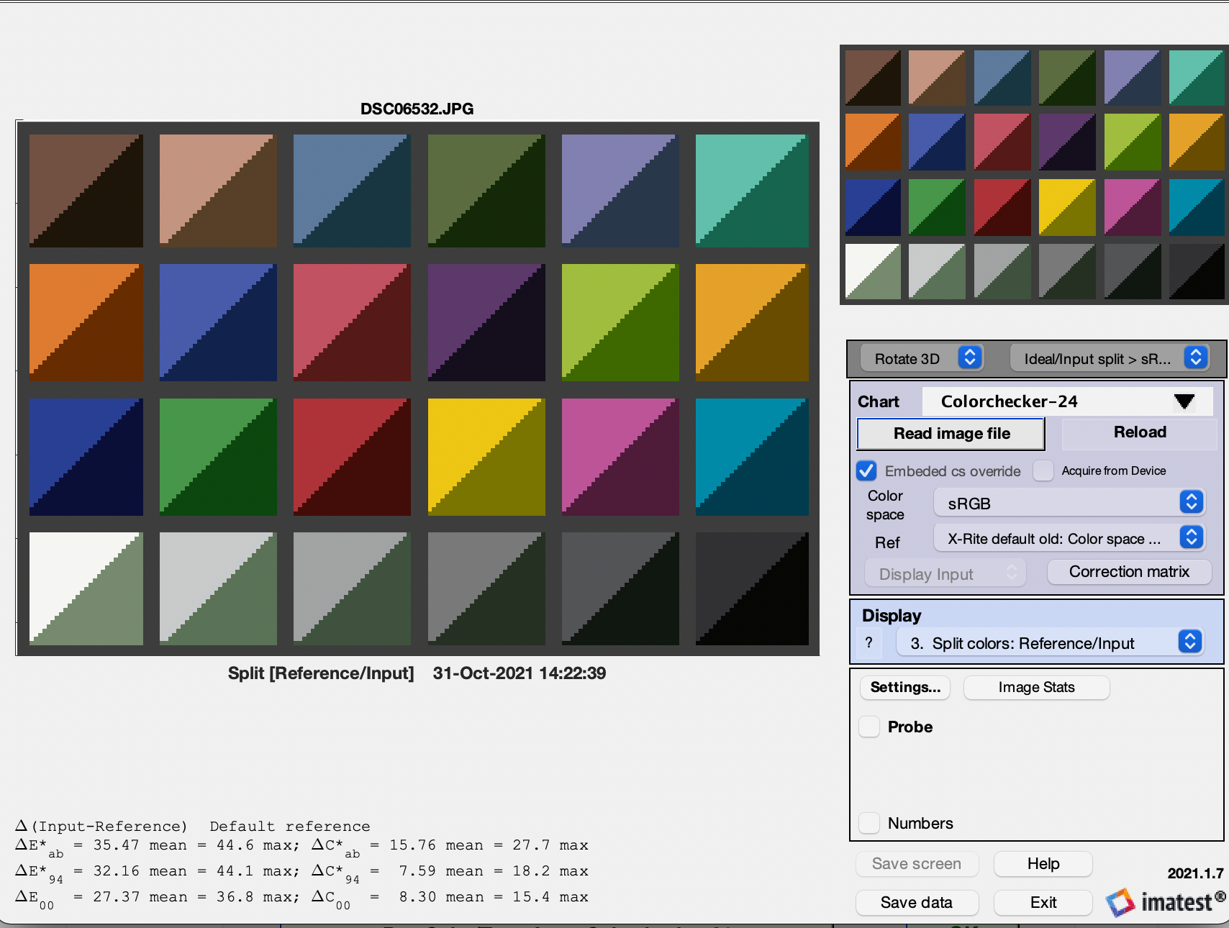

Save data into CSV.format , and get the color matrix

<https://github.com/lighttransport/colorcorrectionmatrix/blob/master/correctColor.py>

This github repository for color correction.